* **Installation of Python**

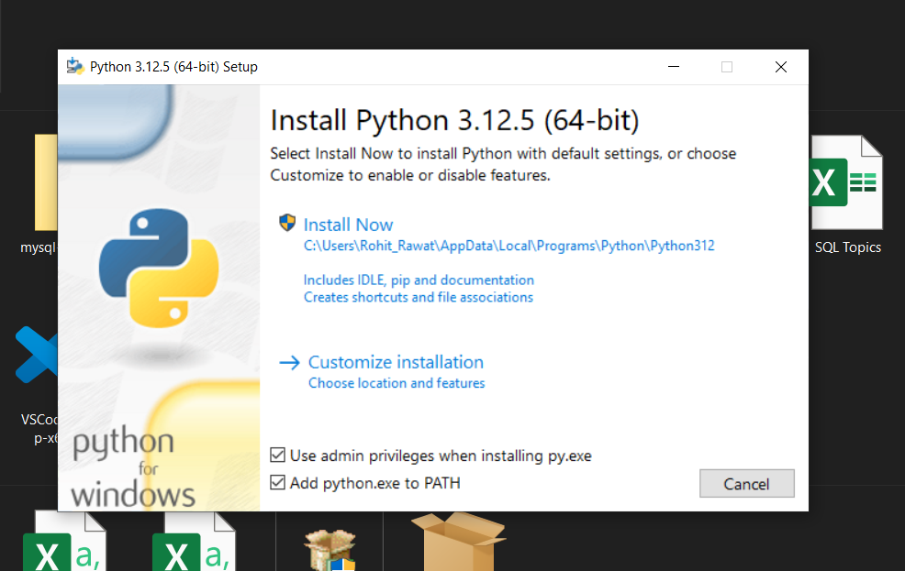

* **Checked the pip package for the installation**

* **Successful installation of python setup**

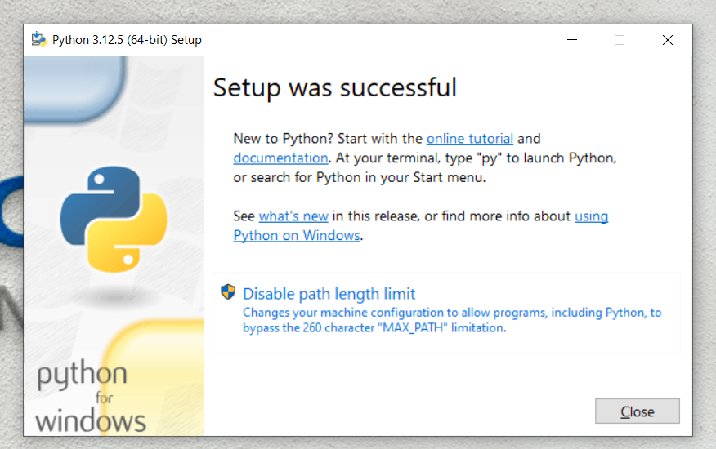

* **Opening the python file location**

* **Scripts folder is created but is empty (*Script folder contains the pip files which are then used to install python libraries*)**

* **Tried installing pip package through cmd**

* **The following image says that pip files are installed in C:\Users\Rohit_Rawat\AppData\Roaming\Python312\Scripts this path but it’s empty.**

